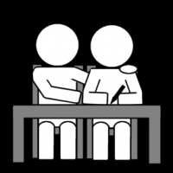

Getting help from an Advocate

Easy Read

Hard words

This book has some hard words.
The first time we write a hard word
the word is in blue
then we write what that word means.

You can get help with this book.

You can ask someone to help you read the book.
You can ask someone to help you know what
the book is about.
You can get someone to help you find more information.

This book is about getting help from an advocate.
An advocate is someone you can trust and who is on your side.
- They can help you to tell people what you want.
- They can help you to tell people what you need.
- They can help you to tell people when something is wrong.
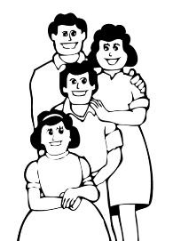
Everyone can have an advocate to help them.

An advocate can be a family member.

An advocate can be a friend you know well.

An advocate can be a support person you know well.

An advocate can be a professional advocate.
A professional advocate is paid to be an advocate for their job.
An advocate can help you make decisions.
An advocate can help you understand information.

An advocate can help you say what you want.
An advocate can help you get the services you need.
An advocate can help you know about your rights
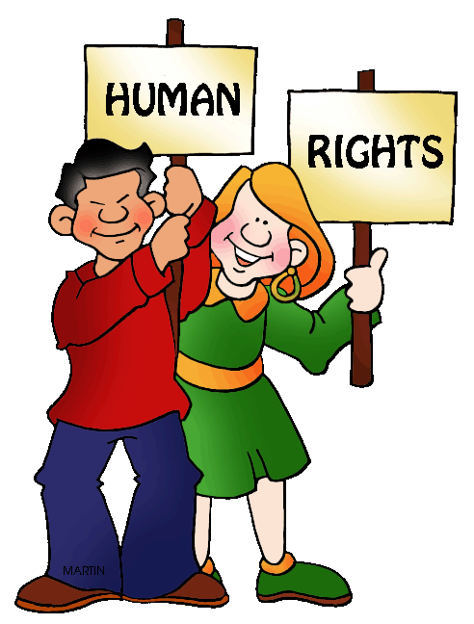
Rights are:
      - Things we can all have
      - Things we can all feel
      - Things we can all get
      - Things we can all do
We all have rights. We all have equal rights.
This means we all have the same rights.
This means we can all expect to be treated fairly.

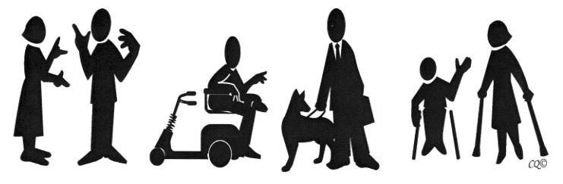
An advocate can help you if you are not treated fairly.

An advocate can help you if you experience discrimination.
Discrimination is when one person does not treat another person the same as everyone else.
Discrimination is when one person is treated unfairly by another person.
An advocate can help you make a complaint.

An advocate can help you write a letter or make a phone call about what happened.

An advocate can help you in a meeting to talk about the problem.

An advocate can help you get advice on legal problems.

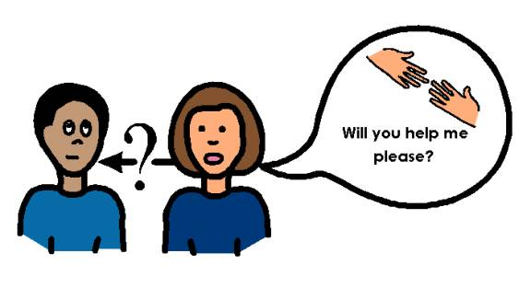
You have the right to ask for help from an advocate if you want that.

If you need one, there are professional advocates working at these places who will try to help you fix the problem.
You or someone you trust, can call to speak to an advocate in Perth:
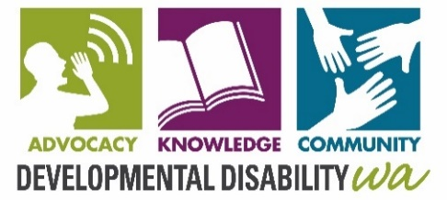
Developmental Disability WA
9420 7203
City West Lotteries House
2 Delhi Street, West Perth

Ethnic Disability Advocacy Centre
9388 7455
320 Rokeby Road
Subiaco

Explorability
6361 6001
1/9 Parkes St
Cockburn Central

Sussex St Community Law Service
6253 9500
29 Sussex St
East Victoria Park

Midlas
9250 2123
23 Old Great Northern Hwy
Midland

Personal Advocacy Service
9275 5388
28 Holdhurst Way
Morley

People with Disabilities WA
9420 7279
City West Lotteries House
2 Delhi Street, West Perth

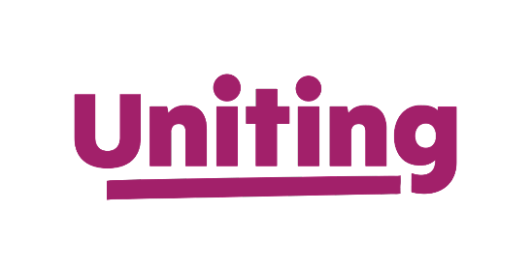
Your Say
1300 663298
10/5 Aberdeen Street
Perth

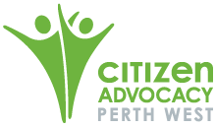
Citizen Advocacy
9445 9991
2A/ 28 Guthrie Street
Osborne Park
* Staffed by volunteers

Regions - Outside Perth:

Advocacy WA
9721 6444
4 Plaza Street
South Bunbury

Individual Disability Advocacy Service (IDAS)
0447253516 – Geraldton (Mid-West)
114 Sanford St Geraldton

9842 8566 – Albany (Great Southern)
125 Grey St Albany

0452 239 500 – Kalgoorlie (Goldfields)
42 Wilson St Kalgoorlie

Kimberley Disability Advocacy 8, Lot 642, Cable Beach Road Broome
9192 7898 – Kimberley
Pilbara Disability Advocacy
Offices 2 & 3, 15 Iron Ore Parade
Newman
9175 0032 - Pilbara

