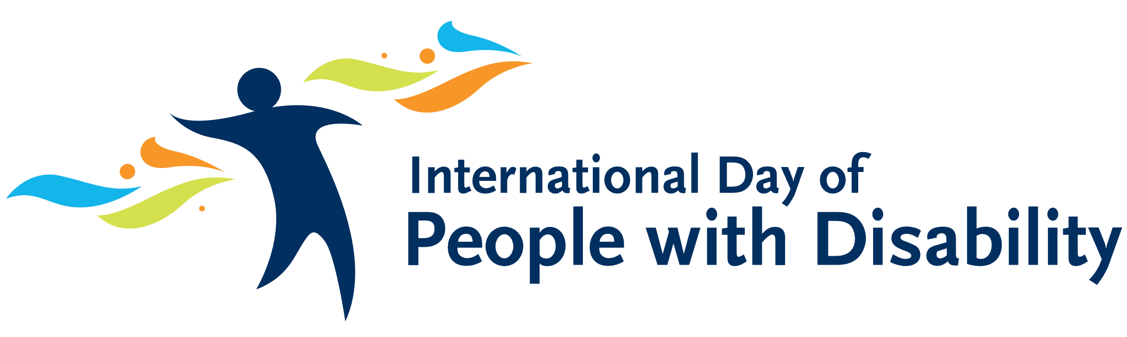
2020 Guidelines
Introduction
The International Day of People with Disability (IDPwD) is a United Nations sanctioned day that is celebrated internationally.
The Developmental Disability Council of Western Australia is offering sponsorship to support organisations and groups to hold inclusive community events or activities on or around International Day of People with Disability on 3 December 2020.
Events and activities must celebrate people with disability and raise awareness of the importance of welcoming, accessible and inclusive communities.
Amount
Sponsorship of up to $1000 is available for organisations to deliver community events or activities, including: disability festivals, sporting events, disability forums, workshops, seminars, award ceremonies; and art, music, dance and other cultural events. Online virtual events are also acceptable due to COVID-19.
Key dates
Applications open 26 October 2020
Applications close 10:00am Monday 9 November 2020
Notification of result from 12 November 2020
Who is eligible to apply
- Incorporated, not-for-profit, non-government organisations
- Local government authorities
- Un-incorporated organisations or community groups, applying through the auspice of an incorporated body or a local government authority.
Who is not eligible to apply
- Federal or state agencies
- Individuals
- Commercial for-profit organisations
- Unincorporated not-for-profit community sector organisations (unless applying through an incorporated body or a local government authority)
Criteria for activities
Applicants must demonstrate that the event will:
- Be held on or around IDPwD (3 December 2020)
- Celebrate people with disability and raise awareness of the importance of access and inclusion across the community
- Be inclusive and accessible
- Be open to the community.
Note: To give your application the best chance of success, please ensure that you have addressed each of the above criteria in the Application Form.
Conditions of sponsorship
Successful applicants must agree and abide by the following terms and conditions.
- The event must be accessible to people of all abilities. (For tips and guidelines on how to hold an IDPwD event, visit https://www.idpwd.com.au/get-involved/communities/
- Recipients will be required to provide high resolution photographs of the event and consent for their use by Developmental Disability Council of WA and/or Department of Communities.
- Recipients must return the money received back to the Developmental Disability Council of WA.

Assessment and notification
All sections must be completed on the Application Form so that the IDPwD Panel can assess your application against the selection criteria.
All applicants will be notified in writing of the outcome of their application from 13 November 2020. It is important to note that not every application that meets the criteria will necessarily receive funding.
How to apply
Complete the Application Form and return it to the Developmental Disability Council of WA by no later than 10am Monday 9 November 2020.
Email to: beth.marchbank@ddwa.org.au
Deliver to: Developmental Disability WA, City West Lotteries House, 2 Delhi St, West Perth
Post to: As above – Mail is only delivered on Tuesdays and Thursdays.
Please note: applications will not be accepted after the closing date.
Successful applicants
Image and promotional consent
All successful applicants are required to provide Developmental Disability Council of WA with high-resolution photos of the event. Applicants must ensure participants who appear in photographs have provided their consent to the applicant for their use in Developmental Disability Council of WA and/or Department of Communities digital and print publications. A Photo Release Form template is provided, however applicant’s may wish to use their own.
Information about events will also be posted on the Developmental Disability Council of WA website, e-newsletters and social media platforms and further promoted via media releases.
If you are holding a public event you can register your event on the Australian Government website promoting IDPwD, https://www.idpwd.com.au/events/event-registrations/. This website also has some resources to assist in planning, hosting and promoting your event.
If promoting events via digital media such as websites, Facebook, Instagram or Twitter, we encourage organisations to hashtag photographs with
#idpwd
#awesternaustraliaforeveryone
Enquiries
Enquiries: ddwa@ddwa.org.au or 9420 7203

This initiative is proudly supported by

